**Welcome Back Turtle Assignment:**

1. 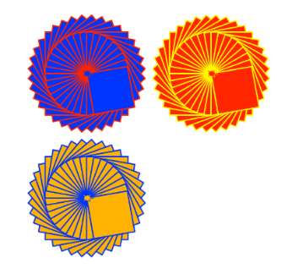Create a Python Turtle program to do the following:
2. Draw an interesting shape using multiple basic shapes   
   and pen colors.
3. Use the **goto(x,y)** function to move the starting point for the shape   
   to a different location on the output window.
4. Use a **counted loop** to draw multiple copies of your shape at different   
   positions on the output window.
5. Use the **input()** function to ask for a number of times to repeat the shape. Use this number to control the repeat of the counted loop.
6. Extension. Check the repeat number input to make sure it is a valid number and that it is between the range of 1 to 6 repeats.
7. Use print screen to copy and paste an image of your program output below.

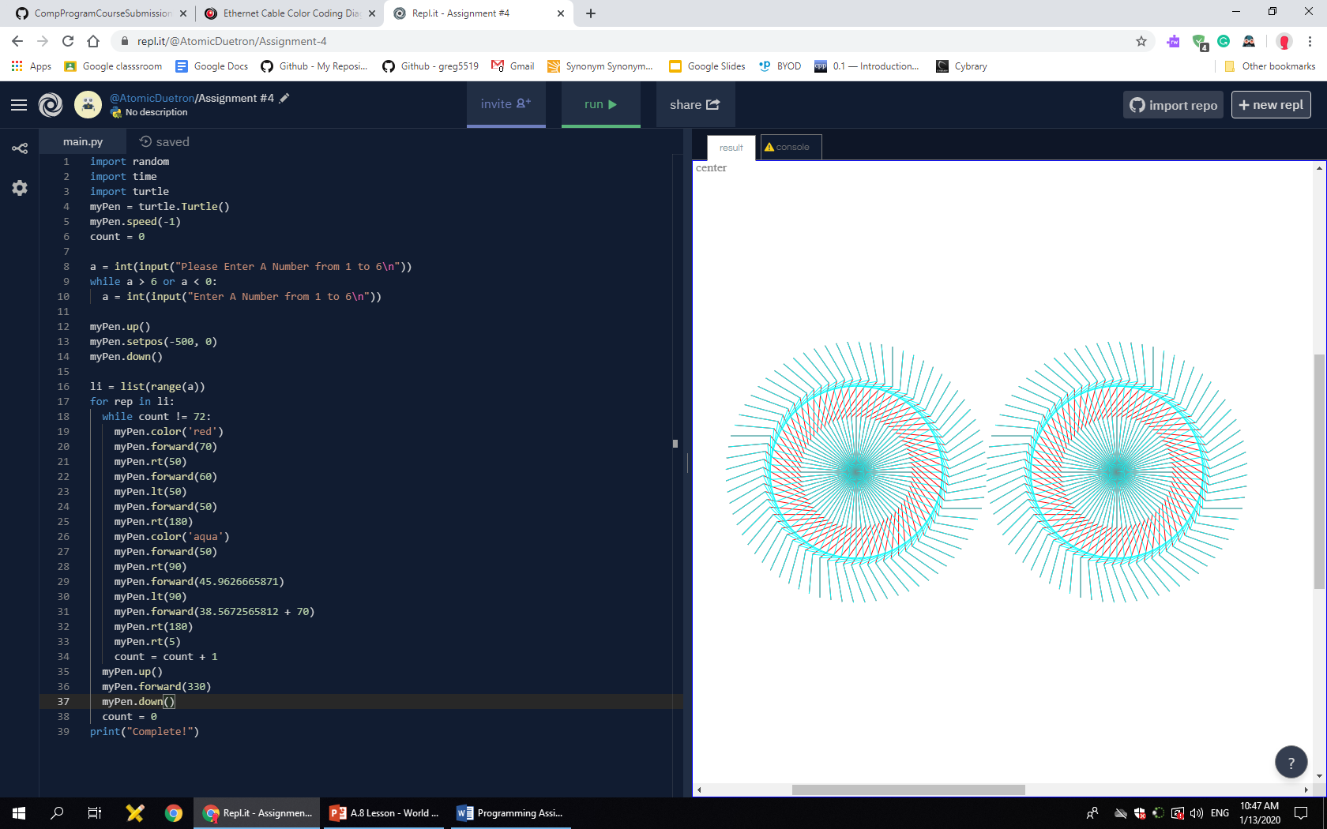

1. Provide a listing of your Python program below.

import random

import time

import turtle

myPen = turtle.Turtle()

myPen.speed(-1)

count = 0

a = int(input("Please Enter A Number from 1 to 6\n"))

while a > 6 or a < 0:

a = int(input("Enter A Number from 1 to 6\n"))

myPen.up()

myPen.setpos(-500, 0)

myPen.down()

li = list(range(a))

for rep in li:

while count != 72:

myPen.color('red')

myPen.forward(70)

myPen.rt(50)

myPen.forward(60)

myPen.lt(50)

myPen.forward(50)

myPen.rt(180)

myPen.color('aqua')

myPen.forward(50)

myPen.rt(90)

myPen.forward(45.9626665871)

myPen.lt(90)

myPen.forward(38.5672565812 + 70)

myPen.rt(180)

myPen.rt(5)

count = count + 1

myPen.up()

myPen.forward(330)

myPen.down()

count = 0

print("Complete!")